- Titre du projet.

Water cycle and isotopes between low and high latitudes of the southern hemisphere, an integrative perspective

- Coordonnées du coordinateur/proposant principal (adresse, téléphone, mel).

A. Landais, Laboratoire des Sciences du Climat et de l’Environnement,

- Noms des co-proposants et laboratoires impliqués.

C. Genthon, Laboratoire de Météorologie Dynamique

4) Objectifs scientifiques et argumentaire pour un soutien IPSL.

Climate and water cycle reconstruction over the last centuries and prediction should be improved in the southern hemisphere (e.g. last IPCC report). First, direct observations are scarce (e.g. mainly basic Automatic Weather Station - AWS - in Antarctica dates since the 50’s and satellite observations). As a consequence, climate and water cycle reconstructions are largely dependent on proxy measurements such as water isotopes in polar ice cores, even over the last century. Second, climate and water cycle reconstructions using models should be improved. In particular, problems have been identified for (1) estimations of precipitation amount (large discrepancies among models over the austral ocean and the ice-sheet), (2) description of particular atmospheric processes associated with cloud microphysics and exchanges between surface and atmosphere in polar regions and (3) seasonal to interannual evolution of the locations of the westerlies and subtropical jet and associated air mass trajectories. The first two limits have strong influence on our estimate of the evolution of the surface mass balance in Antarctica (Agosta et al., 2018; Grazioli et al. 2017). The third aspect has important direct consequences for the atmospheric dynamics in this region but also indirect consequences such as the links between westerlies, CO₂ outgassing and sea ice extent in the austral ocean (Saunders et al. 2018; Menviel et al. 2018; Holland and Kwok, 2012).
This project will provide (1) a better description of water cycle dynamic in the austral ocean down to Antarctica at interannual scale as well as (2) an improved transfer function between climate / water cycle and water isotopes in this region. We will combine measurements of precipitations characteristics, water isotopes in the vapor and condensed phases and outputs of models (some of them including isotopes). Our aim is to take advantage of the latest developments in data observations, global and regional modeling and to focus on a specific region in the Indian oceanic sector, from la Reunion to Antarctica.
Strong progresses are being done in modeling the water cycle dynamic and water isotopes (implemented in the LMDZ model, Risi et al. 2010). In particular, specific developments were performed recently in Antarctica both with the LMDZ model (e.g. Vignon et al., 2017) and using regional models (MAR, one of the two best models for modeling Antarctica, with arrival at IPSL of C. Agosta). The current implementation of isotopes in the MAR model (post-doc of C. Agosta) is an essential tool to improve the climate and water cycle reconstructions from polar ice core before the observational period (started in the 50’s) and make the link with prediction. In parallel, several instruments documenting the water cycle (micro-rain radar, LIDAR) across atmospheric layers and the isotopic composition of water, snow and water vapor have recently been deployed in the southern hemisphere:
- Antarctica (Dumont d’Urville station referred to DDU in the following, Dome C station, within the APRES3, ANTARCTIC-SNOW, COMBINISO and ADELISE projects) (Casado et al. 2016 Genthon et al. 2017; Breant et al., submitted)
- Lower latitudes of the Indian Ocean (La Réunion within the ISOTROPIC project) (Guilpart et al., 2017).

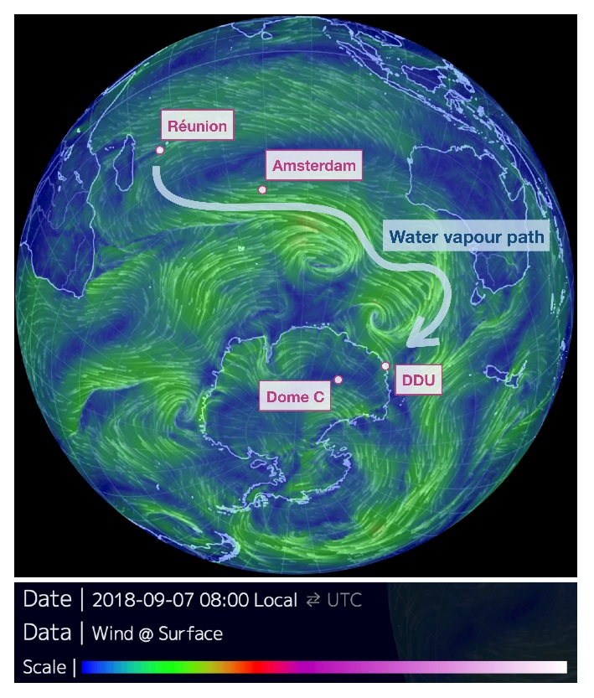 | 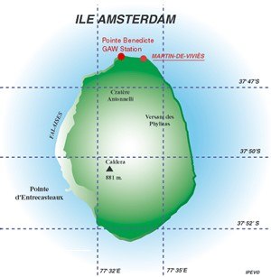

Figure:
Left: Map with location of the different instrumented sites concerned by this project, as well as an exemple of the atmospheric water trajectory (wind direction in white and wind speed in shaded colors) the 07/09/2018 at 6:00 UTC (https://earth.nullschool.net/#2018/09/08/0600Z/wind/surface/level/orthographic=-270.96,-59.70,299).
Right: Map of the Amsterdam Island. We propose to install the instrument at Pointe Bénédicte.
- Objective 1: Better understand and model polar processes
DDU and Dome C present different characteristics that should be taken into account for the study of surface mass balance in Antarctica. Accumulation rate is very limited at Dome C (~30 kg m⁻² yr⁻¹) with significant deposition during clear sky and strong exchanges between the surface snow and the atmosphere. Accumulation rate is much stronger in DDU (~300 kg m⁻² yr⁻¹) and katabatic winds are very important so that a large portion of the snow sublimates in the atmosphere (Barral et al., 2014; Grazioli et al., 2017). These processes also strongly influence the water isotopic composition. The recent instrumentation deployed on these two sites is key to improve the microphysics of the clouds implemented in both LMDZ and MAR model. Constraints for these models are thus being brought by the combination of data documenting the vertical water column on these sites as well as isotopic data measured in parallel on rain and snow samples.
- Objective 2: Trace the water cycle and isotopes from the source (Indian Ocean) to the archive sites (Antarctica)
In addition to their sensitivity to local processes, water isotopes are also good tracers of the air mass trajectories, and marine air trajectories entering in Antarctica often travel first over DDU and then on Dome C. To complement this moist air path (Fig. 1), useful information can be obtained on the corresponding evaporative regions in the Indian Ocean by continuous measurements of the water vapor isotopic composition performed in the Maïdo observatory in La Réunion (Guilpart et al., 2017), but the distance is long to Antarctica. One objective of our present project aims at closing the gap in the dynamic of the water cycle between low and high latitudes on the continuum between the Indian Ocean and Antarctica through the addition of a new station of observations for 2 years (2019-2021) at the Amsterdam Island. In addition, we want to link the whole set of observations over the 4 stations thanks to climate models equipped with isotopes.
- Objective 3: Better understand the subtropical jet dynamics
Amsterdam Island (37.62°S, 77.52°E), located in the southern Indian Ocean, is in the water pathway between La Reunion and DDU (Fig. 1). Its climate is dominated by the subtropical ridge and the band of strong westerly flows. In the austral winter, the westerlies dominate the flow regime while in the austral summer, the northward shift of subtropical jet leads to a more important northerly component to the flow regime, hence trajectories originating from the region of La Réunion (Miller et al., 1993).
Another deliverable brought by our project is to look at the dynamic of the subtropical jet oscillating between the latitude of La Réunion in austral winter and Amsterdam Island in austral summer. As mentioned above, the isotopic composition of water vapor and precipitation is sensitive to air mass trajectories so that such dynamic should be imprinted in the records of both islands. In fact, an extensive study of the drivers of the isotopic composition of the water vapor at La Réunion recently showed that the influence of the subtropical westerly jet dominates the water isotopic signal at night (Guilpart et al., 2017).
- Novelty and consistency of the action
While we do not propose innovative instrumentation in this project, the combination of instruments to be deployed at Amsterdam Island is quite unique to study the dynamic of the water cycle and cloud microphysics: (a) micro-rain radar to sample through the depth of the lower atmosphere, (b) rain gauge for obtaining information on precipitation amount, precipitation type and water isotopic composition of precipitation, (c) laser spectroscopy instrument. A huge set of data will be put together and hopefully be integrated in the IPSL data center. Also the combination of measurements along the transect La Réunion, Amsterdam Island, Dumont d’Urville and Dome C during several years is the first of this type and should be compared with the measurements performed along cruises in the sector where we have collaborators (e.g. ACE, Polarstern).
This project will participate to a new dynamic at IPSL around the water cycle thematic in the southern hemisphere and benefit from the arrival of C. Genthon (LMD) and C. Agosta (LSCE) and reinforce the observation and modeling centers of IPSL.

5) Moyens
This project is related to several projects, some of them just finished (ISOTROPIC, but continuous measurement of isotopes is still ongoing at La Réunion; COMBINISO) and other ongoing (APRES3, ANTARCTIC-SNOW, ADELISE). Through these projects, most of the equipment is already acquired for providing the whole picture of the water cycle and associated water isotopic composition.
- Field missions:
Logistic of the field missions will be supported by IPEV for Amsterdam Island within the funded IPEV ADELISE project: Pointe Bénédicte (Fig. 1) has already a well-equipped observatory with continuous monitoring of ozone, radon and greenhouse gases as well as an automated weather station. If this project is funded, a 4 week field mission would occur from November to December 2019 to install the instruments for documenting the evolution of the water vapor isotopic composition in Pointe Bénédicte. Then, a Volontaire Service Civil (VSC) will take in charge the daily check of the instruments and sampling of the precipitation on a weekly basis. A second field mission would take place from November to December 2020 to check the instruments, perform calibration and install a micro-rain radar to further characterize precipitation type and regime. Note that the micro-rain radar is unfortunately not available in 2019 but we do not want to delay the first mission because everything is already in place and working fine in the other 3 stations and we want to obtain the longest period for parallel measurements of water vapor isotopic composition in the 4 different sites.

Data treatment processing
The data for precipitation amount and water isotopic composition will be acquired continuously in Amsterdam Island from November 2019 and data treatment will be performed remotely and almost in real time at LSCE and LMD using routine algorithms already in use at IPSL (e.g. for the SIRTA observatory). The same data analyses will be performed in parallel for the 3 other sites concerned by this project (La Réunion, DDU and Dome C). In addition, we will analyze the isotopic composition (δ¹⁸O, d-excess and possibly ¹⁷O-excess) on weekly water samples. Finally, we plan to use back-trajectories to isolate the periods when La Réunion – Amsterdam Island – DDU and Concordia are on the same main water mass trajectory and focus on these periods for studying the evolution of water vapor isotopic composition over the 4 sites. At the end of the project, the data will be made freely available to the international community.

Modeling

The modeling aspect of this project is twofold:
- Global modelling: several modelling outputs already exist for the LMDZ-iso model on the instrumental period. We want to use these outputs to study the link in the model between the variations of positions and strengths of the westerlies / subtropical jet and water isotopic signatures (Objective 3).
- Regional modelling: the MAR model has been extensively adapted and run over Antarctica with the aim to improve the description of polar processes needed for proper representation of the water cycle. MAR with isotopes should be available in the first 6 months of the project (mid-2019). A first simulation compared to available observations will be performed over Antarctica to improve isotopic description and cloud micro-physics in the model (Objective 1). The MAR model will then be set up in a domain including the four observation sites (Objective 2). This domain will have the same dimension as the current Antarctic domain (Agosta et al., 2018) but will be centered on the Indian Ocean, and will be nudged in LMDZ-iso. This will allow a continuous tracking of the water isotope change along the water pathway from the oceanic sources to the Antarctic sites in the MAR polar model. The measurements of the 4 sites will be of high value to evaluate the isotope implementation in MAR. The model outputs will then be used to derive the large scale circulation patterns which relate the isotopic signal at the 4 sites.

Collaborations

- Group of Alexis Berne, ETH Zürich: access of precipitation radar at both DDU and Dome C
- Group of Franziska Aemisegger, ETH Zürich: ACE campaign
- Group of Alexey Ekaykin, AARI St Petersburg: ACE campaign
- Group of Martin Werner, AWI Bremerhaven: Polarstern campaign, continuous water vapor isotopic measurements in Kohnen (Atlantic side of Antarctica), confrontation of LMDZ-iso and ECHAM-iso models.

9) Programmes nationaux ou européens auxquels le projet est associé.

Projets juste terminés : ANR ISOTROPIC et ERC COMBINISO (2013-2017)
Projets en cours : ANR APRES3, Fondation de Monaco ANTARCTIC-SNOW, LEFE ADELISE, IPEV ADELISE et NIVO2

11) Références.

Agosta, C., Amory, C., Kittel, C., Orsi, A., Favier, V., Gallée, H., van den Broeke, M. R., Lenaerts, J. T. M., van Wessem, J. M., and Fettweis, X. (2018, in review) Estimation of the Antarctic surface mass balance using MAR (1979–2015) and identification of dominant processes, The Cryosphere Discuss., https://doi.org/10.5194/tc-2018-76.

Barral, H., C. Genthon, A., Trouvilliez, C. Brun, C. Amory, 2014. Blowing snow in coastal Adélie Land, Antarctica : three atmospheric moisture issues, The Cryosphere, 8, 1905–1919, doi:10.5194/tc-8-1905-2014.

Bréant, C., Leroy Dos Santos, C., Casado, M., Fourré, E., Goursaud, S., Masson-Delmotte, V., Favier, V., Agosta, C., Cattani, O., Prié, F., Golly, B., Orsi, A., Martinerie, P., Landais, A., Coastal water vapor isotopic composition driven by katabatic wind variability in summer at Dumont d’Urville, coastal East Antarctica, Earth and Planetary Science Letters, Submitted

Casado, M., Landais A. et al. 2016. “Continuous Measurements of Isotopic Composition of Water Vapour on the East Antarctic Plateau.” Atmospheric Chemistry and Physics Discussions: 1–26. http://www.atmos-chem-phys-discuss.net/acp-2016-8/ (March 21, 2016).

Genthon, C et al. 2017. “Atmospheric Moisture Supersaturation in the Near-Surface Atmosphere at Dome C, Antarctic Plateau.” Atmospheric Chemistry and Physics 17(1): 691–704. https://www.atmos-chem-phys.net/17/691/2017/.

Grazioli, Jacopo, Genthon C. et al. 2017. “Measurements of Precipitation in Dumont d’Urville, Adélie Land, East Antarctica.” The Cryosphere 11(4): 1797.

Guilpart, E., F. Vimeux, S. Evan, J. Brioude, J.‐M. Metzger, C. Barthe, C. Risi, and O. Cattani (2017), The isotopic composition of near‐surface water vapor at the Maïdo observatory (Reunion Island, southwestern Indian Ocean) documents the controls of the humidity of the subtropical troposphere, J. Geophys. Res. Atmos., 122, 9628–9650, doi: 10.1002/2017JD026791.

Holland P. R. & Kwok R. Wind-driven trends in Antarctic sea-ice drift. Nat. Geosci. 5, 872–875 (2012).

Menviel, L et al. 2018. “Southern Hemisphere Westerlies as a Driver of the Early Deglacial Atmospheric CO2 Rise.” Nature Communications 9(1): 2503. https://doi.org/10.1038/s41467-018-04876-4.

Risi, C., Bony, S., Vimeux, F., and Jouzel, J. 2010. “Water-Stable Isotopes in the LMDZ4 General Circulation Model: Model Evaluation for Present-Day and Past Climates and Applications to Climatic Interpretations of Tropical Isotopic Records.” Journal of Geophysical Research Atmospheres 115(12).

Saunders, Krystyna M et al. 2018. “Holocene Dynamics of the Southern Hemisphere Westerly Winds and Possible Links to CO2 Outgassing.” Nature Geoscience 11(9): 650–55. https://doi.org/10.1038/s41561-018-0186-5.

Vignon, E., Hourdin, F., Genthon, C., Van de Wiel, B., H. Gallée, J.-B. Madeleine, J. Beaumet, Journal of Advances in Modeling Earth Systems, doi: 10.1002/2017MS001184, December 2017, Modeling the Dynamics of the Atmospheric Boundary Layer Over the Antarctic Plateau With a General Circulation Model

